

Dr. Jeffrey, Smith inc.

2017-04-25

Dr. Smith

38068 Douglas Flat Suite 632, North Ginastad, CA 01288

Phone: 3780242042

Fax: 89489785

**Re:** Susan, Gould

**PHN:** 9622284900

**Birthdate:** 10-Jan-1950

**Address:** 8486 Andrea Lane Suite 614, New James, KY 36152

**Patient number:** 9431587670

To Whom It May Concern:

This is a medical letter to state the above patient is pregnant with expected delivery date of 18-Jun-2025. Hoping this information is satisfactory for your requirements.

Thank you.

Sincerely,

Dr. Jeffrey, Smith

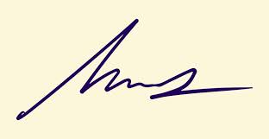

FRCS© NCMP

Clinical Assistant Professor, UBC

Department of Obstetrics and Gynecology SMH